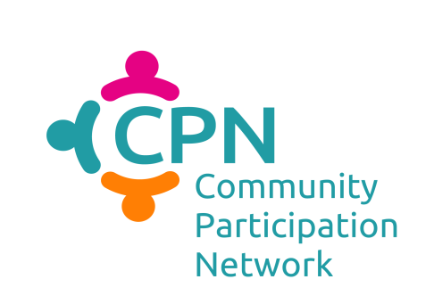
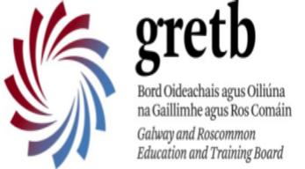

Practical Self Advocacy Course 8 weeks

Every Friday 10.30am-2.30pm

Sept 29, Oct 06,13,20,27, Nov 10,17 and 24.

GRETB Training Centre, Mervue Business Park, Monivea Rd, Mervue, Galway.

To express your interest and register for a place on the course contact Sabrina Commins on 087 930 3468 / Sabrina@gcp.ie

All GRETB courses are free to the unemployed or to those who wish to upskill.

CPN are delighted to be working now with the Galway Roscommon Education Training Board (GRETB) to roll out the innovative approach of co-facilitation within the community structure of the local GRETB for the Galway and Roscommon region.

What is Co-Facilitation?

Through the past number of years, CPN West has identified and coordinated the delivery of training within the CPN areas of CPN Galway and CPN Mayo. Based on CPN West member and course participant feedback, it was recognised:
- People valued peer learning, and training by peers, in the area of advocacy, empowerment and disability awareness.
- Training of this nature should be based in the community. What a wonderful idea, to have training for people with disabilities based in their community, available to everyone!
- CPN Members have a lot to offer in terms of ongoing advice and support. Through training, people are linked in directly to the valuable resources of ETBs, local development companies, family resource centers etc, which can offer continued support beyond the duration of one course.
So, with all of this feedback formally taken on board, CPN Galway approached GRETB and together, with the direct support of DFI and local coordination of Galway City Partnership the following work took place earlier this year:
- GRETB delivered a Facilitation Skills Training Course. Open to the public, this gave previous CPN training course participants a chance to develop their own capacity to be facilitators and support to their peers.
- DFI delivered Disability Awareness training to GRETB tutors.
- Practical Self Advocacy Course to be delivered in the venue of GRETB, co facilitated between a GRETB tutor and a participant of the GRETB Facilitation Skills.

With the support of GRETB we are greatly excited to see this course delivered for the first time by a local GRETB tutor Safia Waller, together with a previous course participant, facilitator Fiona Casey.

With input and continued support from CPN Galway member: Galway City Partnership throughout the course and after, participants will find ongoing opportunities, advice and support with their local communities.

What is the CPN Practical Self Advocacy Course?
This course has been designed to help you to name the challenges and barriers that you may face as a person with a disability in Ireland today. It aims to enable you to identify supports and resources within your local community and to create an action plan to empower you in your daily life.

Course Content:
By the end of the course participants will:
- Identify hopes, desires and expectations for the future.
- Identify barriers and difficulties that may be faced.
- Understand Advocacy and
- Self-Advocacy.
- Reflect on what it means to be a person with a disability in Ireland.
- Improve communication, group discussion and active listening skills.
- Have an understanding of personal rights and responsibilities.
- Explore the area of equality and diversity and look at legislation relating to people with disabilities.
- Learn about inclusion and participation.
- Create a persona action plan for the future.
- Identify resources and supports within your local community.

Course Tutors:
Fiona Casey - Previous participant on the Practical Self Advocacy Course, local activist in the area of disability and member of Muscular Dystrophy Ireland. Fiona recently completed the GRETB Facilitation Skills course.
Safia Waller - Tutor in Further Education & Training with a BA in Community and Family Studies and a Professional Diploma in Further Education through NUIG. Safia has taught social studies in the Galway Technical Institute (GTI), delivered Community and Youth Leadership Skills courses and completed the CPN Disability Awareness Training delivered through GRETB.

GRETB and CPN Galway are delighted to come together for first time this September to deliver this training to you, in your local community based ETB.

GRETB:

It is the mission of Galway and Roscommon ETB to be a key provider of quality, inclusive education opportunities and support services that enable young people and adults to reach their full potential and contribute in a positive and meaningful way to society.
www.gretb.ie
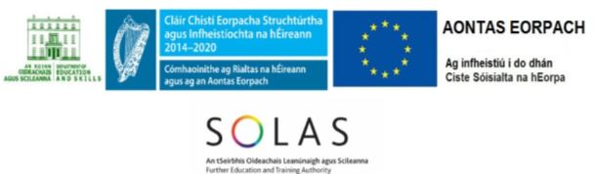
Galway and Roscommon ETB is funded by:

Community Participation Network (CPN) West:

In the context of local government reform, and the development of Public Participation Networks (PPNs), the Community Participant Network (CPN) West was established in 2015 in the West of Ireland to help support the capacity of and direct representation of people with disabilities within local community structures. The CPN West is made up of locally based voluntary disability organisations, DFI member organisations, local partnerships, family resource centres, and local community development project companies within the Limerick, Galway and Mayo counties.

The work of CPN West is being supported nationally by the Disability Federation of Ireland (DFI). www.disability-federation.ie

Within CPN Galway, Sabrina Commins of Galway City Partnership is coordinating this course. Please contact Sabrina on 087 930 3468 / Sabrina@gcp.ie to book your place or for further details.

The work of the CPN is being supported nationally by the Disability Federation of Ireland (DFI).
The Disability Federation of Ireland is a company limited by guarantee not having share capital, registered in Dublin.
Registered No. 140948, CHY No 6177.
Update published on 10 September 2017.

